Question 1:
What is the output of the following code?
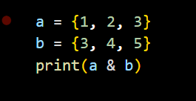
A) {1, 2, 3, 4, 5}
B) {}
C) {3}
D) Error: unsupported operand type(s) for &

Question 2:
Which data structure is best suited for implementing recursion?
A) Queue
B) Stack
C) Linked List
D) Heap

Question 3:
What will be the output of the following code?
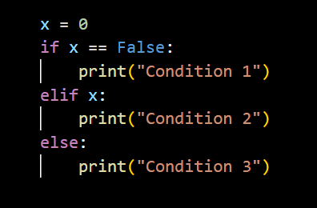
A) Condition 1
B) Condition 2
C) Condition 3
D) No output

Question 4:
What will be the output of the following code?
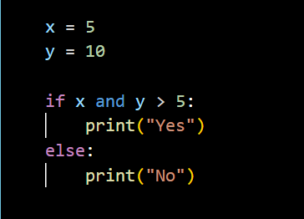
A) Yes
B) No
C) Error
D) None
Question 5:
What will be the output of the following code?
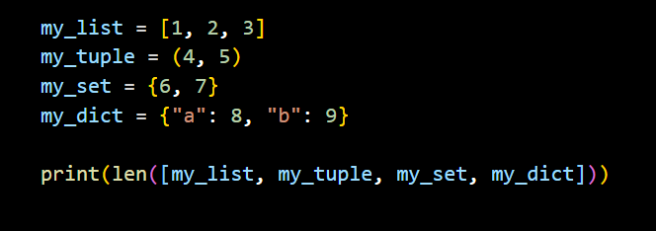
A) 4
B) 9
C) Error
D) 10

Question 6:
What will be the output of the following code?

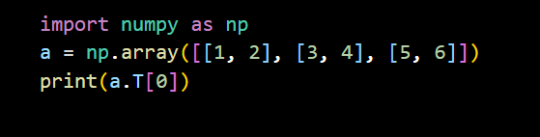
A) [1 3 5]
B) [1 2]
C) [1 3 5 0]
D) Error

Question 7:
What will be the result of this operation?
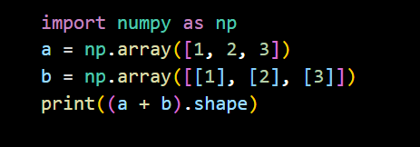
A) (3, 3)
B) (3,)
C) (1, 3)
D) Error

Question 8:
What will be the output of the following code?
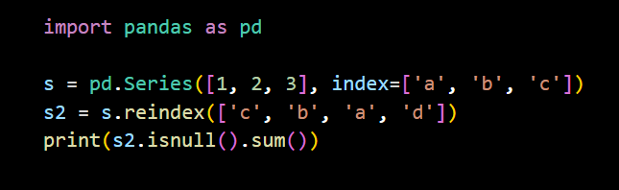
A) 0
B) 1
C) 3
D) Error

Question 9:
What will be the output of the following code?
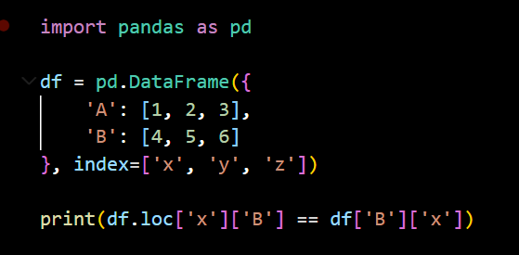
A) True
B) False
C) Error: KeyError
D) TypeError

Question 10:
Given the following DataFrame with a MultiIndex:
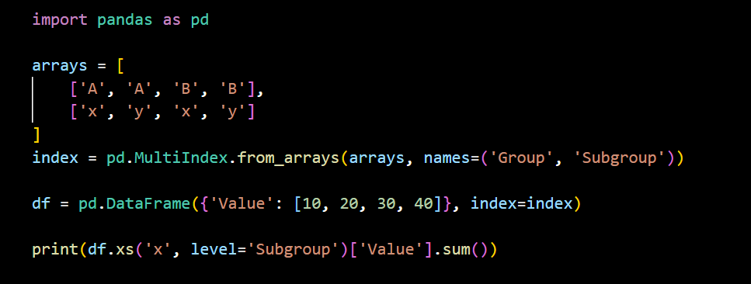
A) 10
B) 30
C) 60
D) 40

Question 11:
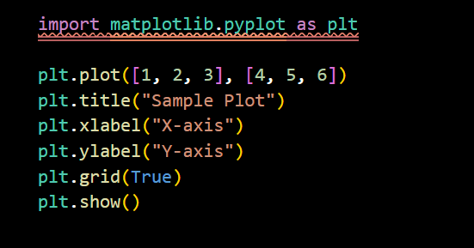
Which of the following statements is True about the above code?
A) The grid will not appear unless plt.grid('on') is used
B) The plot will show with both labels and grid
C) The title will not appear without plt.suptitle()
D) The x-axis label will be "Y-axis"

Question 12:
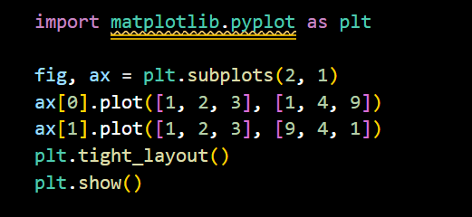
What does plt.tight_layout() do here?
A) Automatically adjusts subplot spacing to prevent overlap
B) Removes padding between subplots
C) Shrinks the figure size
D) Has no effect on this layout

Question 13:
What will happen when you run the following code?
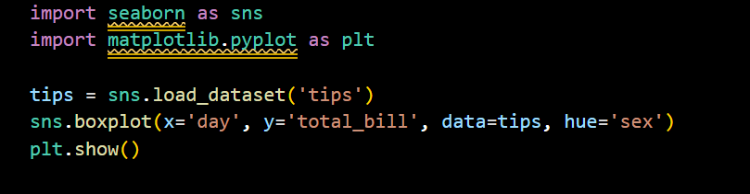
A) It will raise an error because hue is not allowed in boxplot()
B) It will show a boxplot split by day and grouped by sex
C) It will plot total bills by sex only
D) The plot will have only one box per day
Question 14:
What will be the result of the following code?
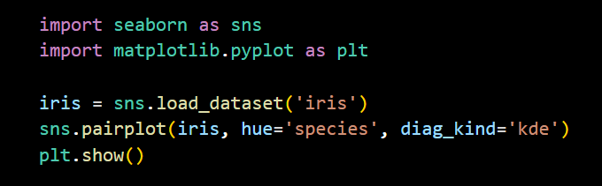
A) It raises an error because pairplot() does not support diag_kind='kde'
B) It plots all numerical features against each other, coloring by species, with histograms on the diagonal
C) It plots all numerical feature pairs, using KDE plots on the diagonal and colors for each species
D) It shows only the diagonal plots with KDE for each feature

Question 15 :
What will the following code produce?
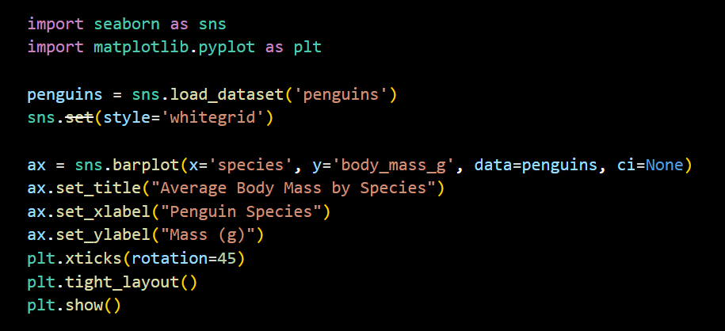
A) A bar plot with default titles and labels
B) A bar plot with customized title and rotated x-axis labels
C) A line plot with rotated y-axis labels
D) An error due to using set_xlabel() on a Seaborn plot

Question 16:
Which of the following statements about standard deviation is true?
A) A higher standard deviation means data points are closely clustered around the mean
B) Standard deviation is always negative if the mean is negative
C) Standard deviation measures the spread of data around the mean
D) A standard deviation of zero means the data is normally distributed

Question 17:
Which of the following statements about a 95% confidence interval is correct?
A) It means 95% of the population data lies within the interval
B) It means there's a 95% chance the sample mean lies within the interval
C) It means 95% of all such intervals calculated from repeated samples will contain the true population mean
D) It guarantees the population mean lies within the interval for this sample
Question 18:
In a two-tailed hypothesis test, a researcher obtains a p-value of 0.03. The chosen significance level (α) is 0.05. Which of the following interpretations is correct?
A) There is a 3% chance the null hypothesis is true
B) The result is not statistically significant because 0.03 < 0.05
C) We reject the null hypothesis because the data is unlikely under the null
D) The p-value tells us the probability that the alternative hypothesis is correct

Question 19:
In a multiple linear regression model, suppose you get the following output:
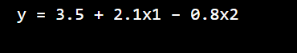
Which of the following is the correct interpretation of the coefficient of x2?
A) When x2 increases by 1, y decreases by 0.8, holding x1 constant
B) When x2 increases by 1, y increases by 0.8, regardless of x1
C) The coefficient of x2 indicates it is not significant in the model
D) The value of x2 does not affect the output because its coefficient is negative

Question 20:
Which of the following statements is most accurate about multicollinearity in linear regression?
A) It improves model accuracy by making features more correlated
B) It causes the R² score to decrease even when adding more predictors
C) It leads to unstable coefficient estimates and inflated standard errors
D) It has no impact as long as the p-values are small

Question 21:
Which of the following best describes a key difference between Ridge and Lasso regression?
A) Ridge regression uses L1 penalty which can eliminate features by setting coefficients to zero
B) Lasso regression shrinks all coefficients equally and never removes any
C) Ridge regression can reduce model variance but keeps all features, whereas Lasso can perform feature selection
D) Both Ridge and Lasso always produce identical models if α (regularization strength) is the same

Question 22:
In a binary classification task, which of the following situations most likely leads to a high accuracy but poor model performance?
A) The model has high recall but low precision
B) The dataset is perfectly balanced
C) The model is applied to an imbalanced dataset where the majority class dominates
D) The model has an F1-score close to 1

Question 23:
Which of the following is the best interpretation of the AUC (Area Under the Curve) value in a ROC curve?
A) It measures the proportion of true positives over all actual positives
B) It represents the probability that the classifier ranks a randomly chosen positive instance higher than a randomly chosen negative one
C) It is the area under the precision-recall curve
D) It is always 1 for a good model and 0 for a bad one

Question 24:
Which of the following statements best describes the precision-recall tradeoff when adjusting the classification threshold?
A) Increasing the threshold generally increases both precision and recall
B) Lowering the threshold increases precision but decreases recall
C) Increasing the threshold increases precision but may decrease recall
D) Precision and recall are unaffected by the threshold — only accuracy is

Question 25:
Which of the following statements correctly compares Bagging and Boosting?
A) Bagging builds models sequentially to correct errors, while Boosting builds models in parallel
B) Boosting reduces variance by averaging many weak learners, while Bagging reduces bias by focusing on hard examples
C) Bagging reduces variance by training models in parallel on bootstrapped data, while Boosting reduces bias by training models sequentially to fix previous errors
D) Both Bagging and Boosting only work with decision trees and cannot be used with other models

Question 26:
Which of the following statements is true about the K-Means clustering algorithm?
A) It guarantees finding the global optimum cluster configuration
B) It can work well with categorical data if the number of clusters is large
C) It assigns points to clusters based on minimizing intra-cluster distances
D) It automatically determines the optimal number of clusters using inertia

Question 27:
Which of the following best describes the TF-IDF (Term Frequency–Inverse Document Frequency) representation?
A) It counts the number of times a word appears in a document
B) It gives higher scores to words that appear in many documents
C) It penalizes words that are common across documents and boosts rare but informative terms
D) It converts words into word embeddings using context from surrounding words

Question 28:
Which of the following best distinguishes lemmatization from stemming?
A) Lemmatization always produces shorter word forms than stemming
B) Stemming uses a dictionary, whereas lemmatization uses a rule-based approach
C) Lemmatization returns linguistically valid base forms, while stemming may return incomplete or non-words
D) Both processes yield identical results in most NLP pipelines

Question 29:
Which of the following statements is true regarding differences between TF-IDF and Word2Vec?
A) TF-IDF captures semantic meaning of words based on their context in a sentence
B) Word2Vec converts entire documents into a single sparse vector
C) TF-IDF is a frequency-based method, while Word2Vec learns word embeddings from context using a neural network
D) Both techniques produce dense vectors and are context-aware

Question 30:
Which of the following issues is most likely to arise when applying word-level tokenization on noisy, real-world text data (e.g., social media posts)?
A) It captures sarcasm effectively due to short sentence structures
B) It treats misspellings, emojis, and hashtags as meaningful tokens, potentially exploding the vocabulary
C) It handles different forms of the same word by default using lemmatization
D) It works better than subword tokenization in low-resource languages

Question 31:
Which of the following is a true limitation of the Perceptron algorithm?
A) It can converge even on non-linearly separable data with a large enough learning rate
B) It cannot learn the XOR function because it assumes linear separability
C) It updates weights based on the magnitude of the prediction error
D) It minimizes the mean squared error (MSE) using gradient descent

Question 32:
Which of the following statements about Multilayer Perceptrons (MLPs) is true?
A) An MLP with a single hidden layer can model any function, including non-continuous ones
B) MLPs can learn non-linear decision boundaries due to activation functions like ReLU or sigmoid
C) Without a softmax output layer, MLPs cannot perform regression tasks
D) Adding more hidden layers always guarantees improved accuracy

Question 33:
Which of the following best explains why ReLU is preferred over sigmoid or tanh in deep neural networks?
A) ReLU has bounded output, which stabilizes gradient flow
B) ReLU is nonlinear and always differentiable, so it's better for classification
C) ReLU avoids the vanishing gradient problem by maintaining non-zero gradients for positive inputs
D) ReLU activates all neurons equally, helping faster convergence

Question 34:
Which of the following is a key advantage of the Adam optimizer over standard Stochastic Gradient Descent (SGD)?
A) Adam uses a momentum term that decreases learning rate on large gradients
B) Adam maintains per-parameter learning rates using estimates of both first and second moments of gradients
C) Adam guarantees global convergence on non-convex surfaces
D) Adam eliminates the need for tuning hyperparameters like learning rate or batch size

Question 35:
Which of the following best describes the primary effect of Dropout during training a neural network?
A) It forces the network to reduce the number of layers used during backpropagation
B) It randomly disables neurons at inference time to increase generalization
C) It randomly zeroes neuron outputs during training to prevent co-adaptation and overfitting
D) It adjusts learning rates dynamically based on neuron activity

Question 36:
In a CNN, which of the following design choices is most likely to reduce the spatial dimensions of the feature map without increasing the number of parameters?
A) Increasing the number of filters
B) Using 1x1 convolutions
C) Applying a larger kernel size
D) Using max pooling with stride > 1

Question 37:
Why is "same" padding often preferred over "valid" padding in deep convolutional networks?
A) "Same" padding removes border artifacts by expanding the kernel
B) "Same" padding ensures that the output dimensions are reduced, promoting feature compression
C) "Same" padding preserves spatial dimensions across layers, allowing deeper architectures without shrinking the feature map
D) "Same" padding uses smaller strides to retain fine-grained features

Question 38:
In a convolutional layer, increasing the stride value from 1 to 2 primarily leads to which of the following effects?
A) Increases the depth (number of channels) of the feature map
B) Reduces the spatial resolution of the output feature map
C) Adds more learnable parameters to the model
D) Improves the receptive field without affecting output size

Question 39:
Which of the following statements best explains a potential pitfall of aggressive data augmentation in image classification tasks?
A) It always improves model generalization since it increases the training dataset
B) Excessive transformations can introduce label noise by significantly altering class-defining features
C) Applying geometric transformations reduces the model's ability to learn spatial hierarchies
D) Color-based augmentations make the model invariant to texture, which improves overfitting

Question 40:
Which of the following best describes the difference between a fully connected layer and a convolutional layer in a CNN?
A) Fully connected layers use activation functions, while convolutional layers do not
B) Convolutional layers connect all neurons, while fully connected layers only connect to nearby pixels
C) Fully connected layers treat input as a flat vector, while convolutional layers preserve spatial relationships
D) Convolutional layers always reduce the number of parameters compared to fully connected layers

